PRACTICAL EXAM - SWD392 -FAL25
Date time:
Exam Code:

Question 1: Structural Modeling (3.0 points)
Part A: System Context Diagram (1.0 point)
- Your Diagram:
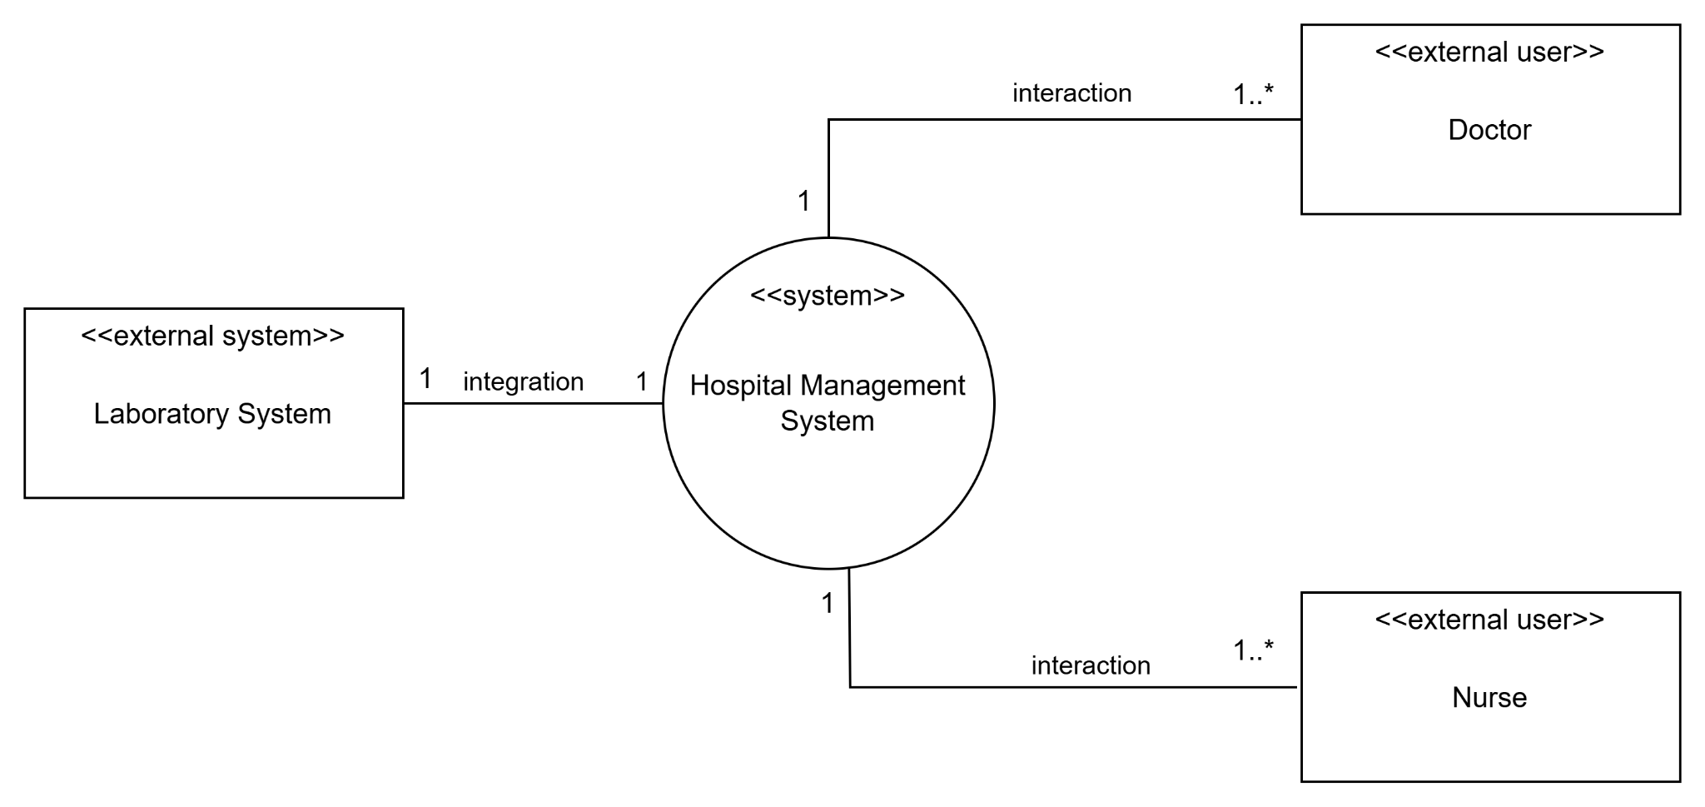

Part B: Conceptual Domain Model (2.0 points)
- Your Diagram:
- Doctor, nurse, hospital, department, resident, attending…
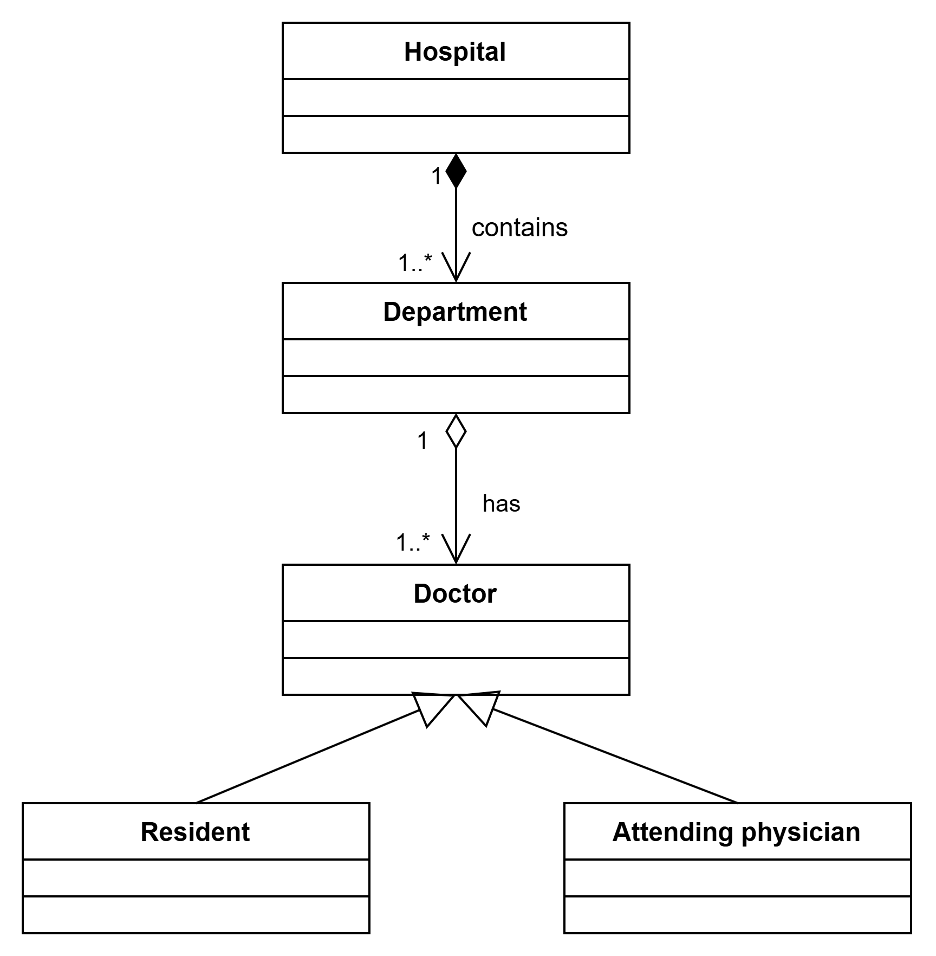

Question 2: Dynamic Interaction Modeling (2.0 points)
- Your Diagram (Sequence Diagram):
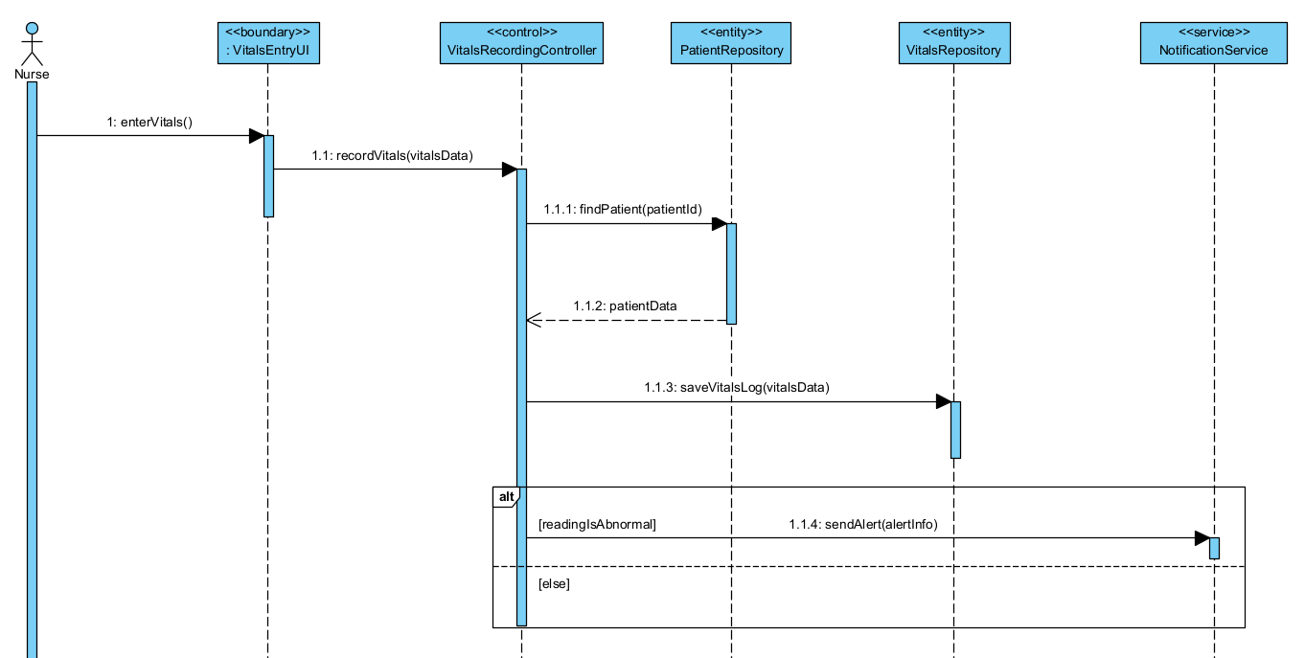

- Brief Explanation:
The sequence diagram illustrates the process of recording a patient’s vital signs. First, the Nurse enters the vital data through the VitalsEntryUI. The UI then sends the data to the VitalsRecordingController for processing. The controller checks whether the patient exists by retrieving the patient record from the PatientRepository. If the patient is found, the controller saves the vital signs as a new record using the VitalsRepository. After saving the data, the system evaluates the reading. If the vital signs are abnormal, the controller calls the NotificationService to send an alert. Otherwise, no notification is sent and the process ends.

Question 3: State Machine Modeling (2.0 points)
- Your Diagram (Statechart Diagram):

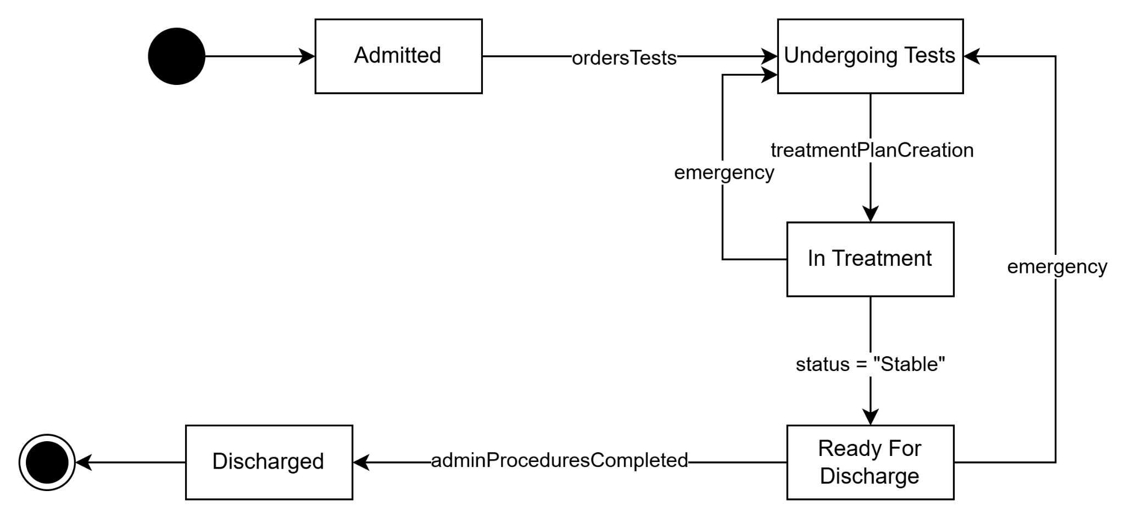

Question 4: Architectural Design and Trade-offs (1.0 point)
- Model:
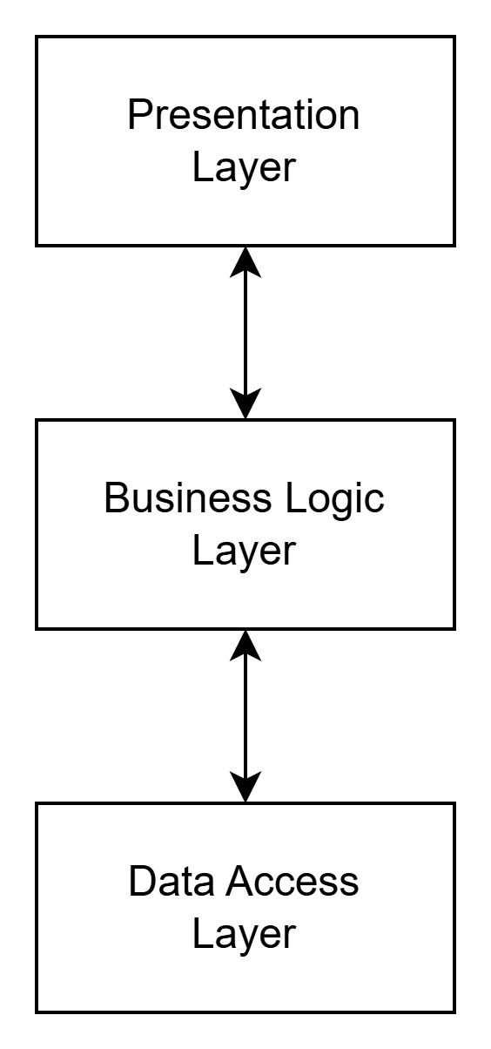
- Interpretation:
Presentation Layer: This layer handles user interaction and displays information to users. It collects user input and sends it to the application layer for processing. In this system, the VitalsEntryUI belongs to the Presentation Layer.
Business Logic Layer: This layer processes the core business logic of the system and coordinates system operations. It receives requests from the presentation layer, executes application logic, and calls services or repositories when needed. In this architecture, VitalsRecordingController and NotificationService are part of the Business Logic Layer.
Data Access Layer: This layer manages data storage and retrieval by interacting with the database. It provides data to the business logic layer and ensures that data operations are properly handled. In this system, PatientRepository and VitalsRepository belong to the Data Access Layer.
The key advantage of this layered architecture is the separation of concerns, where each layer has a clear responsibility. This improves maintainability, scalability, and makes the system easier to modify and test.
Question 5: Design Pattern Identification and Analysis (2.0 points)
- Identification (0.5 points):
  - Pattern Name: Prototype Pattern
  - Family: Creational Design Pattern
- Class Diagram (1.0 point):
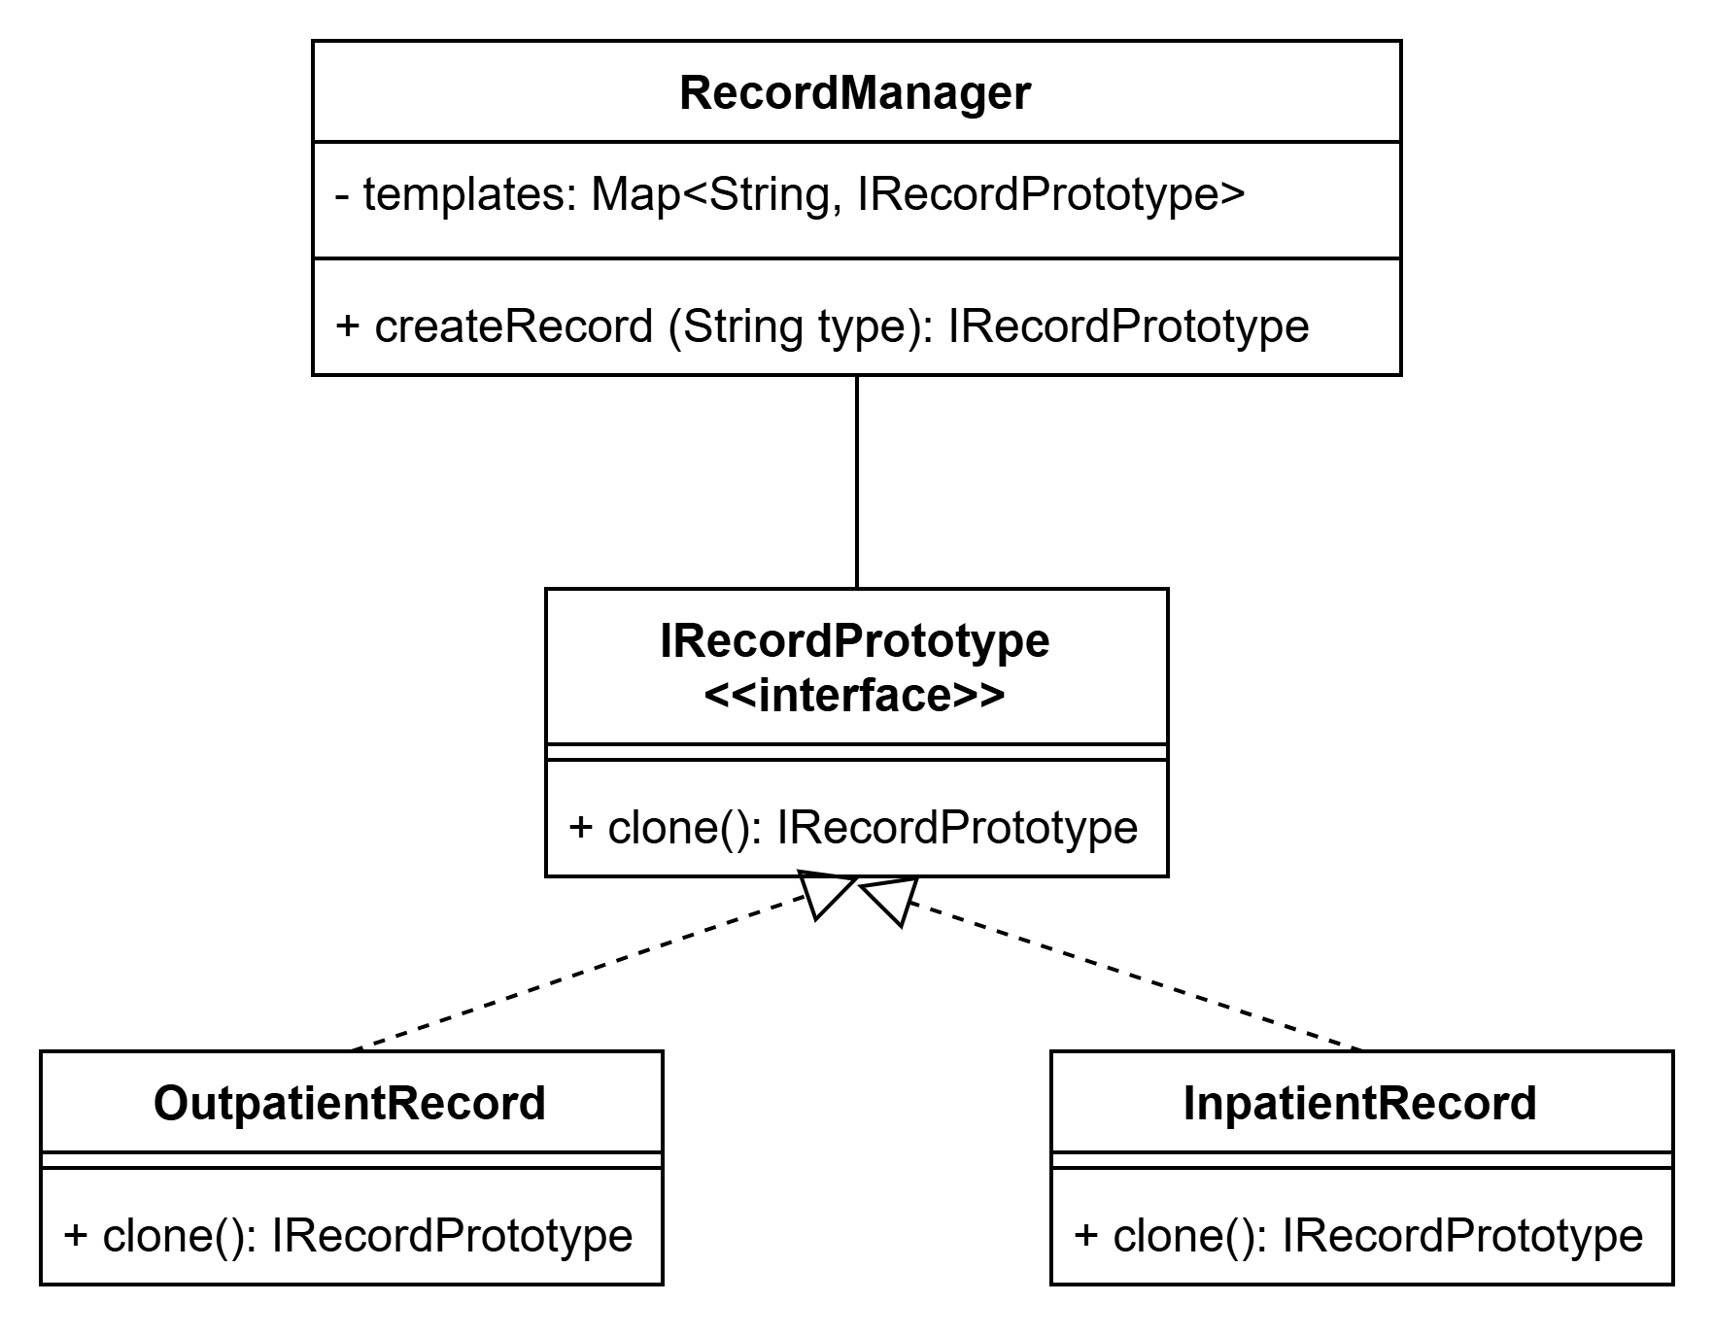
- Explanation (0.5 points):
The code creates new objects by copying an existing instance rather than creating them from scratch. This approach is useful when object creation is expensive or complex. This is the Prototype pattern, which allows objects to be cloned to produce new instances efficiently.
⇒ The code creates new objects by copying an existing instance rather than creating them from scratch; specifically, it defines an IRecordPrototype interface with a clone() method, and concrete classes like OutpatientRecord and InpatientRecord implement this method by returning new instances via copy constructors. A RecordManager maintains a map of pre-configured prototype objects and creates new records by selecting the appropriate prototype and invoking clone(). This approach is useful when object creation is expensive or complex. This is the Prototype pattern, which allows objects to be cloned to produce new instances efficiently.

END OF SUBMISSION

